CREATING A SOCIAL MEDIA AD CAMPAIGN IN FACEBOOK

They are a great way to reach new customers and grow your business. Facebook Ads allow you to target your audience based on demographics like age, gender, location, and interests. You can also target people who have visited your website or engaged with your content on Facebook.
Social media campaigns are a form of advertising that takes place across a brand's social channels. These campaigns often involve several uploads or posts and deliver targeted advertorial content to your audience. They aim to increase brand awareness, drive sales or achieve other business goals.
- Set goals for your Facebook marketing. ...
- Know your Facebook audience. ...
- Publish a mix of content to your Facebook feed. ...
- Post when your followers are most active. ...
- Schedule your Facebook content. ...
- Engage proactively with your audience. ...
- Use Messenger to build relationships with customers.
- Step 1: Define Your Social Media Campaign Goals.
- Step 2: Identify the social media channels you'll use.
- Step 3: Plan your social media campaign strategies.
- Step 4: Choose the metrics you want to monitor.
- Step 5: Create a social media content calendar.
EMPATHY MAP

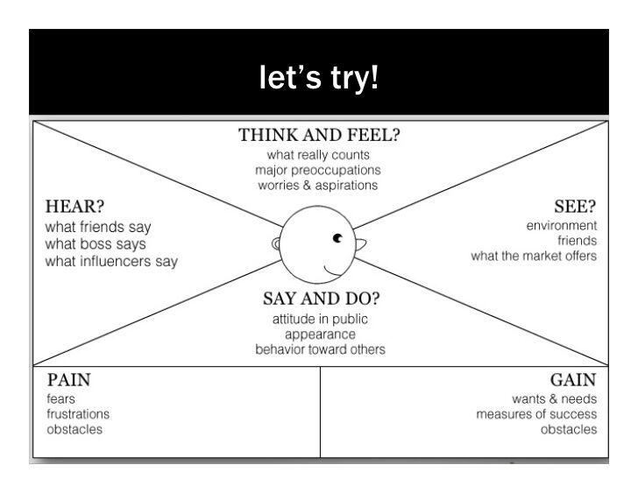

BRAIN STROM ING
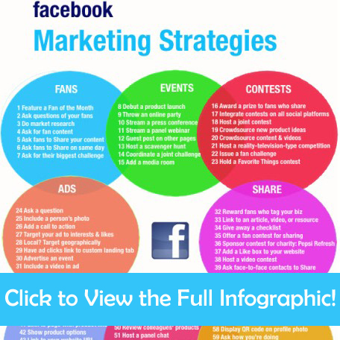

They are a great way to reach new customers and grow your business. Facebook Ads allow you to target your audience based on demographics like age, gender, location, and interests. You can also target people who have visited your website or engaged with your content on Facebook.

